Reqired library for python code

1. pySerial
2. NumPy
3. Tensorflow
4. Python 3.6+

Note: Make sure if in case Clock_Gen IP is locked go to Report IP status and upgrade it.  
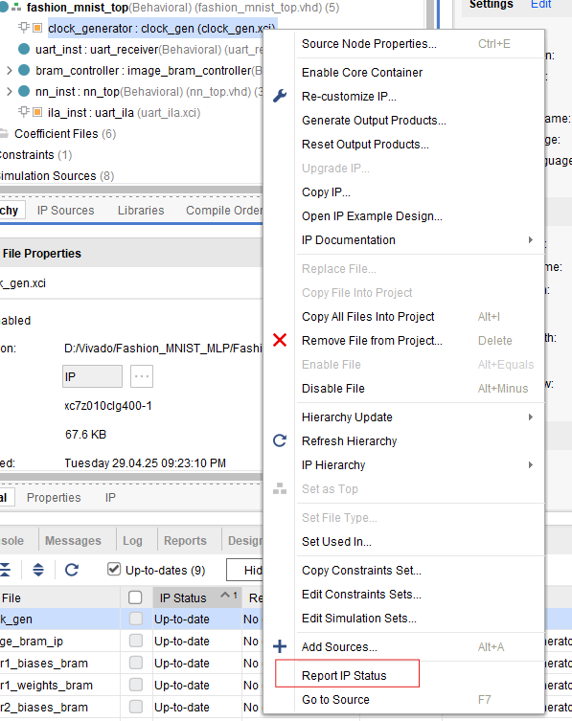

Note: Simulation is going to take around 50-55 minutes to run.

* Place LED pmod on the bottom side of JA.
* Place SSD on botton side of JC and JD
* Place UART on upper side of JE.
* While running send_image.py file user have to Provide their device’s serial port ID.